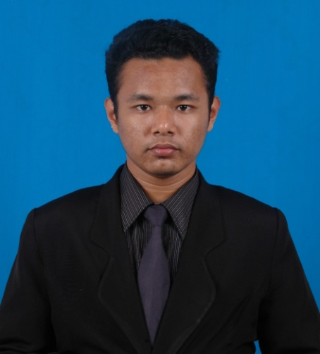

MUHAMMAD AMIRUL HAFIZI BIN ALIAS

B7B RUMAH KAKITANGAN KILANG SAWIT

KETENGAH JAYA,

23300 DUNGUN,

TERENGGANU.

**PERSONAL PARTICULARS**

**Tel [Mobile]**: 0111-6916863 **Email**: mirofixie@gmail.com

Age : 24

Date Of Birth : 13 August 1991

Gender : Male

NRIC : 910813115415

Nationality : Malaysian

Driving Licence : B2, D

Marital Status : Single

Race : Malay

Religion : Islam

Height : 166cm

Weight : 67kg

**EDUCATION BACKGROUND**

2011- 2015 CURRENT RESULTS

**Universiti Utara Malaysia Bachelor of Communication with Honors**

06010 UUM Sintok, Kedah PMK: 2.88 , PMS : 3.28

2010-

**SMK Ketengah Jaya Sijil Tinggi Pelajaran Malaysia(STPM)**

23300,Dungun,

Terengganu

2008-2009

**SMK Ketengah Jaya** **Sijil Pelajaran Malaysia (SPM)**

23300, Dungun

Terengganu

**CARRIER OBJECTIVE**

* Having a stable and challenging career that used my personal capability and creativity where I can enhance my skills and improve my knowledge.
* To work in a company with good working environment in order to contribute to the new technology and be a part of it. Also willing to take a new challenge in fulfilling the company vision and expanding my career.

**SUPPLEMENTARY AND STRENGTH**

Willing to travel : Yes

Willing to be relocated : Yes

Expected monthly salary : Negotiable

Availability : Immediately (Any time)

Personal Strength : Good communication skills

: Positive attitude

: Self motivated

: Able to work under pressure

: Able to work independently (shift)

: Fast learner

**WORK EXPERIENCE**

Mei 2011- Aug. 2011 Cashier at Jem's One Stop Mini Market, Ketengah Jaya

February 2015 - June 2015 Internship in Unit Komunikasi Korporat at Lembaga Kemajuan Terengganu Tengah (KETENGAH)

**EXTRA- CURRICULAR ACTIVITIES**

2013 **Exco Information and Publications** of Silat Gayong Club of UUM

2012 **Committee** **Members** of co-curriculum for Silat Gayong of UUM

2010-2011 **School's Prefect (Exco of Treasurer)** of SMK Ketengah Jaya

2009 **School's Prefect** of SMK Ketengah Jaya

2005- 2007 **Librarian** of SMK Ketengah Jaya

**SKILLS & STRENGTHS**

* Proficient in **Microsoft Word**, **PowerPoint**, **Excel**, and **Adobe Photoshop**
* Speaks fluent Bahasa Malaysia and English
* Fluent in written Bahasa Malaysia and English
* Hardworking and can work under pressure
* Good cooperation in group task
* Easy to accept others concept and ideology

**PERSONAL TRAITS**

I am a very determined, hardworking, yet diplomatic person. Besides, I am able to establish good communication and relationship with team, working under pressure with tight deadline, always willing to share knowledge and learn new things, cautious in whatever I do and tenacity to ensure success in delivery. I am willing to work extra time and travelling.

**REFEREES**

The following person has agreed to provide any additional information regarding my qualification and character:

**COORDINATOR:**

DR. Norhafezah Yusof

COORDINATOR PRACTICUM

TEL: +604-9286703

E-mail: norhafezah@uum.edu.m

**Practicum Supervisor :**

Pn. Muziakma Bt Ali

Assistant Manager,

Unit Komunikasi Korporat,

Lembaga Kemajuan Terengganu Tengah (KETENGAH).

TEL : 013-9442073